ly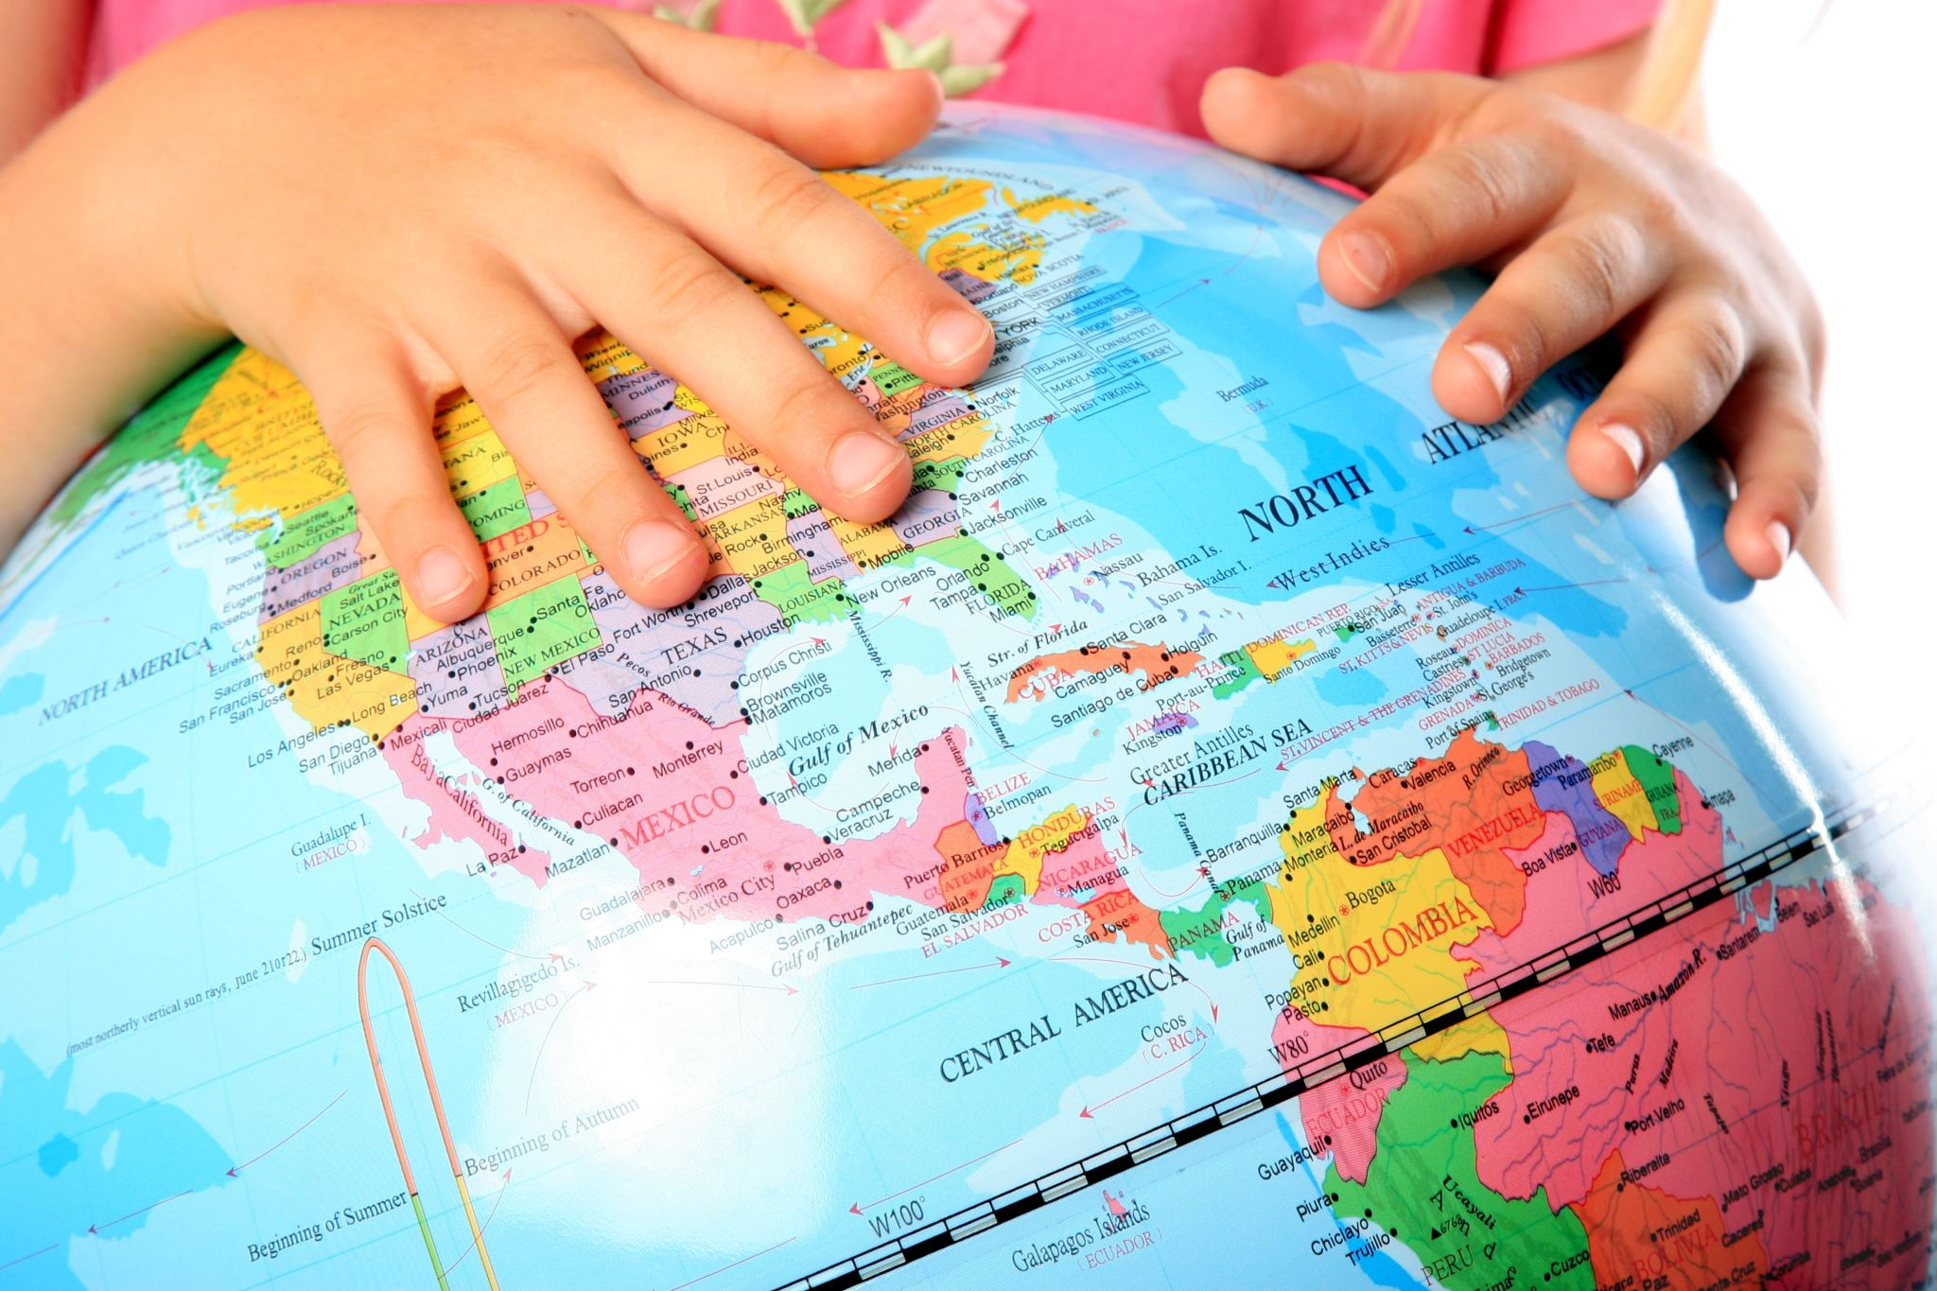
LENT PROJECT 2024
WESTVIEW ELEMENTARY SCHOOL – for newly arriving ESL families
Please Provide for Children:
Gently Used or New Winter Gear – Immediate Need Now,
including coats, gloves, hats, sweaters, boots, socks, shoes (children’s sizes)

School Supplies – Markers, crayons, water bottles, notebooks, pencils, scissors…
Snacks – Individually wrapped. Cheese ‘n crackers, granola bars, goldfish, etc. not candy

Small Stuffed Animals that could fit in a back pack

Gift Cards –grocery

“Every American who ever lived, with the exception of one group,
was either an immigrant himself or a descendant of immigrants.”
Senator John F. Kennedy

The need is great. Items will be delivered to the school weekly, beginning February 10th.
Thank you.

